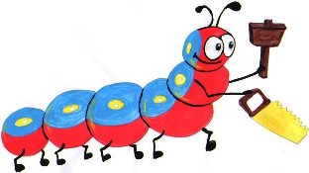

Lyng Primary School Knowledge Organiser

Design Technology

**Bostin Black Country**- How do levers and mechanisms work?

Year 2

Topic: DT

Spring

|  |  |
| --- | --- |
| What Goldilocks and Step On words will I use? | |
| **Spelling** | **Defintion** |
| Design Criteria | A set of rules to help designers focus their ideas and test the success of them. |
| Evaluation | When you look at the good and bad points about something, then think about how you could improve it. |
| Input | The energy that is used to start something working. |
| Linkage | Lengths of material (eg. Metal or card) that are joined together by pivots, so that the links can move as part of mechanics. |
| Mechanical | A collection of parts that work together to create a movement. |
| Output | Output is the motion that happens as a result of starting the input. |
| Pivot | The central point, pin or shaft on which a mechanism turns or swings. |
| Survey | To ask a group of people questions about something and to use their answers to make improvements. |



**Design Brief for pupils:**

* Design and make a moving animal toy for children using levers and linkages.
* Only facial features can be included within the design.

**Purpose:** Fun toy for children to play with and to keep them entertained.

**Audience:** young children aged 4-7.



|  |
| --- |
| Skills and techniques |
| * Create products using levers, wheels and winding mechanics. * Design products that have a clear purpose and an intended user. * Make products, refining the design as work progresses. * Explore how products have been created. * Suggest improvements to existing designs. |

Spring Term

Mechanics

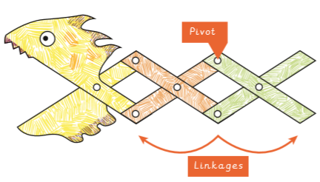

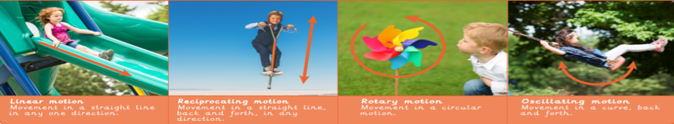

**Four Types of Motion**

**Linear Reciprocating Rotary Oscillating**

**Agreed outcome:**

**Make a moving animal toy for children.**